# CS 255 System Design Document Template

## UML Diagrams

### UML Use Case Diagram

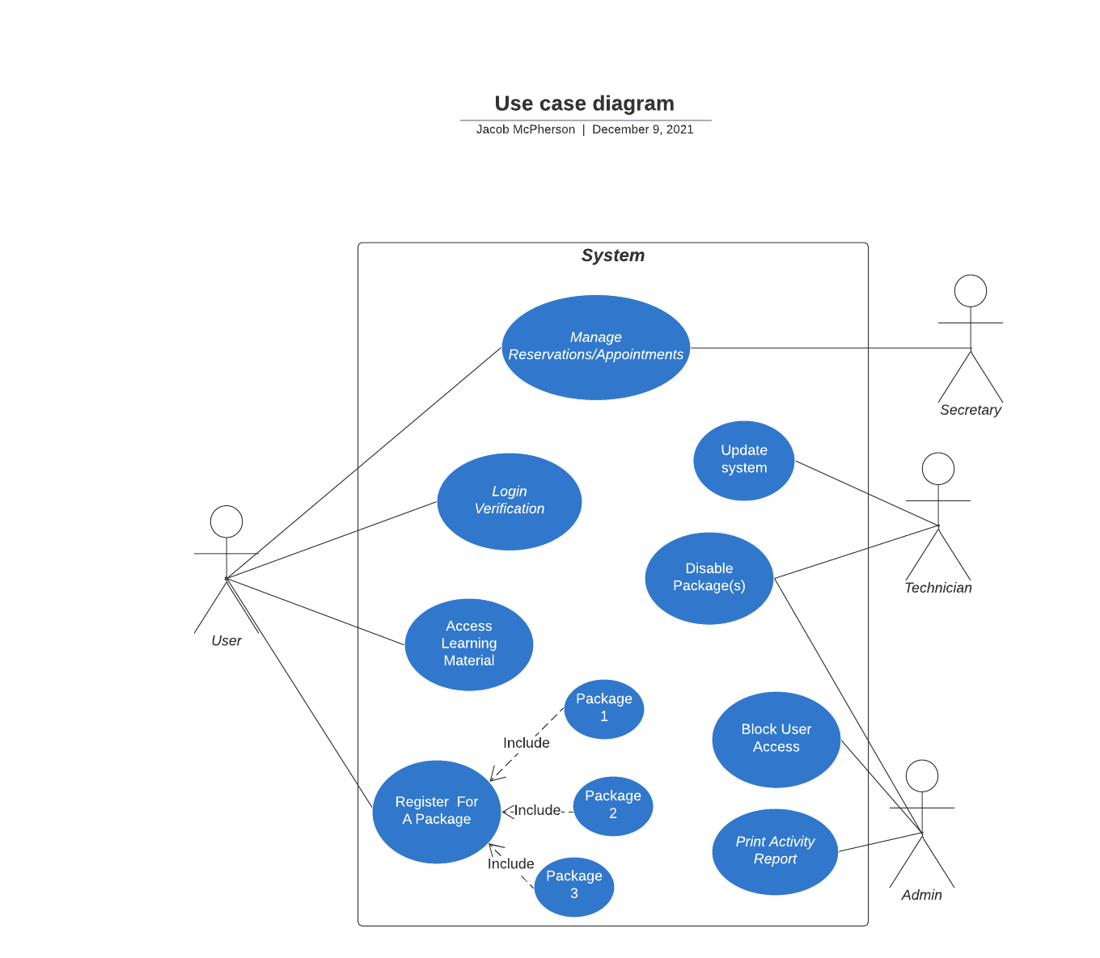

### UML Activity Diagrams

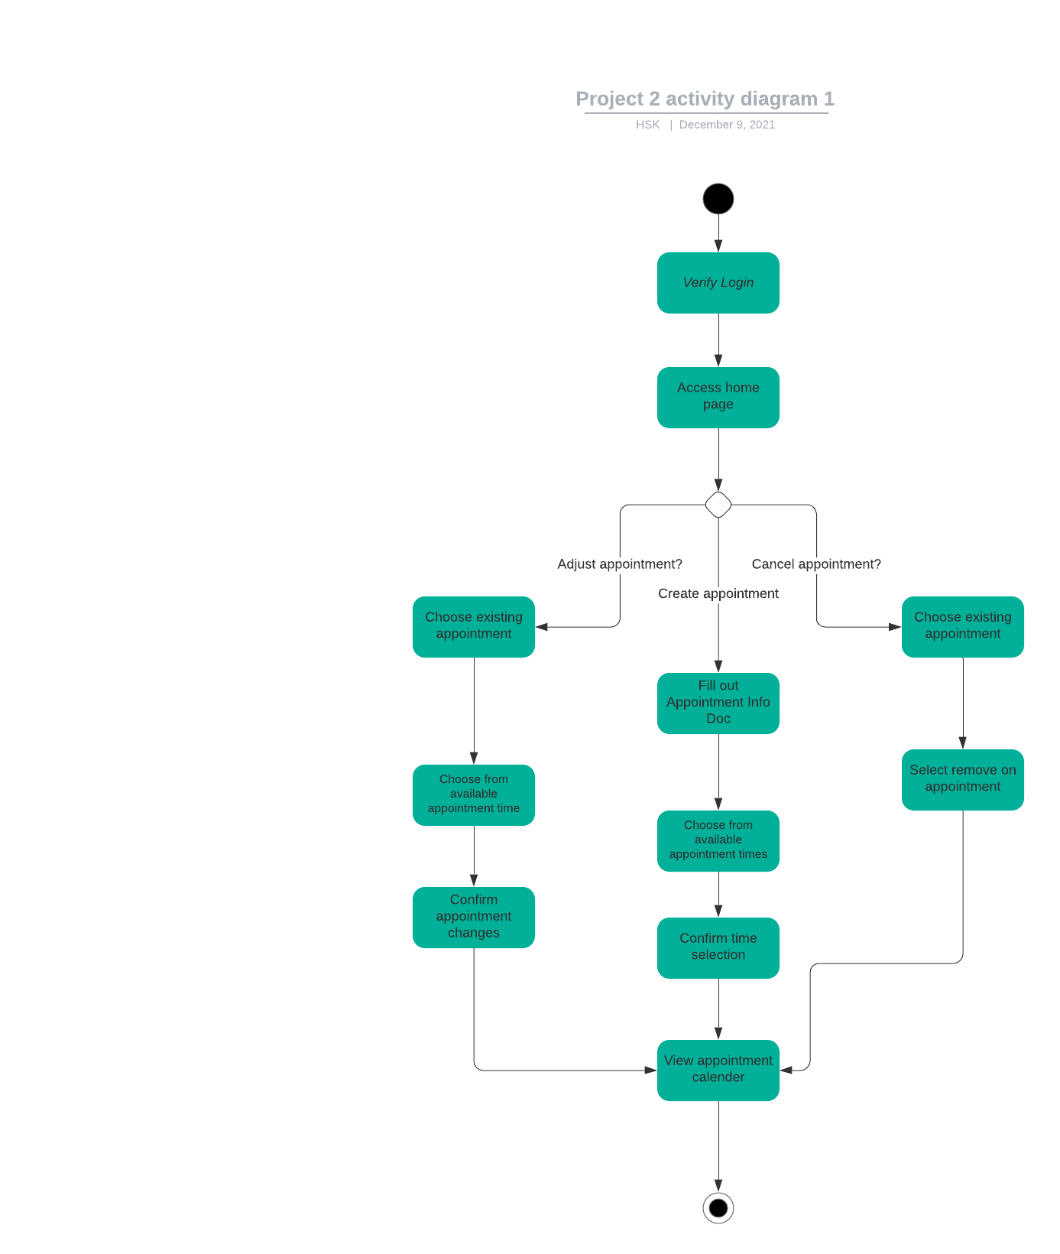

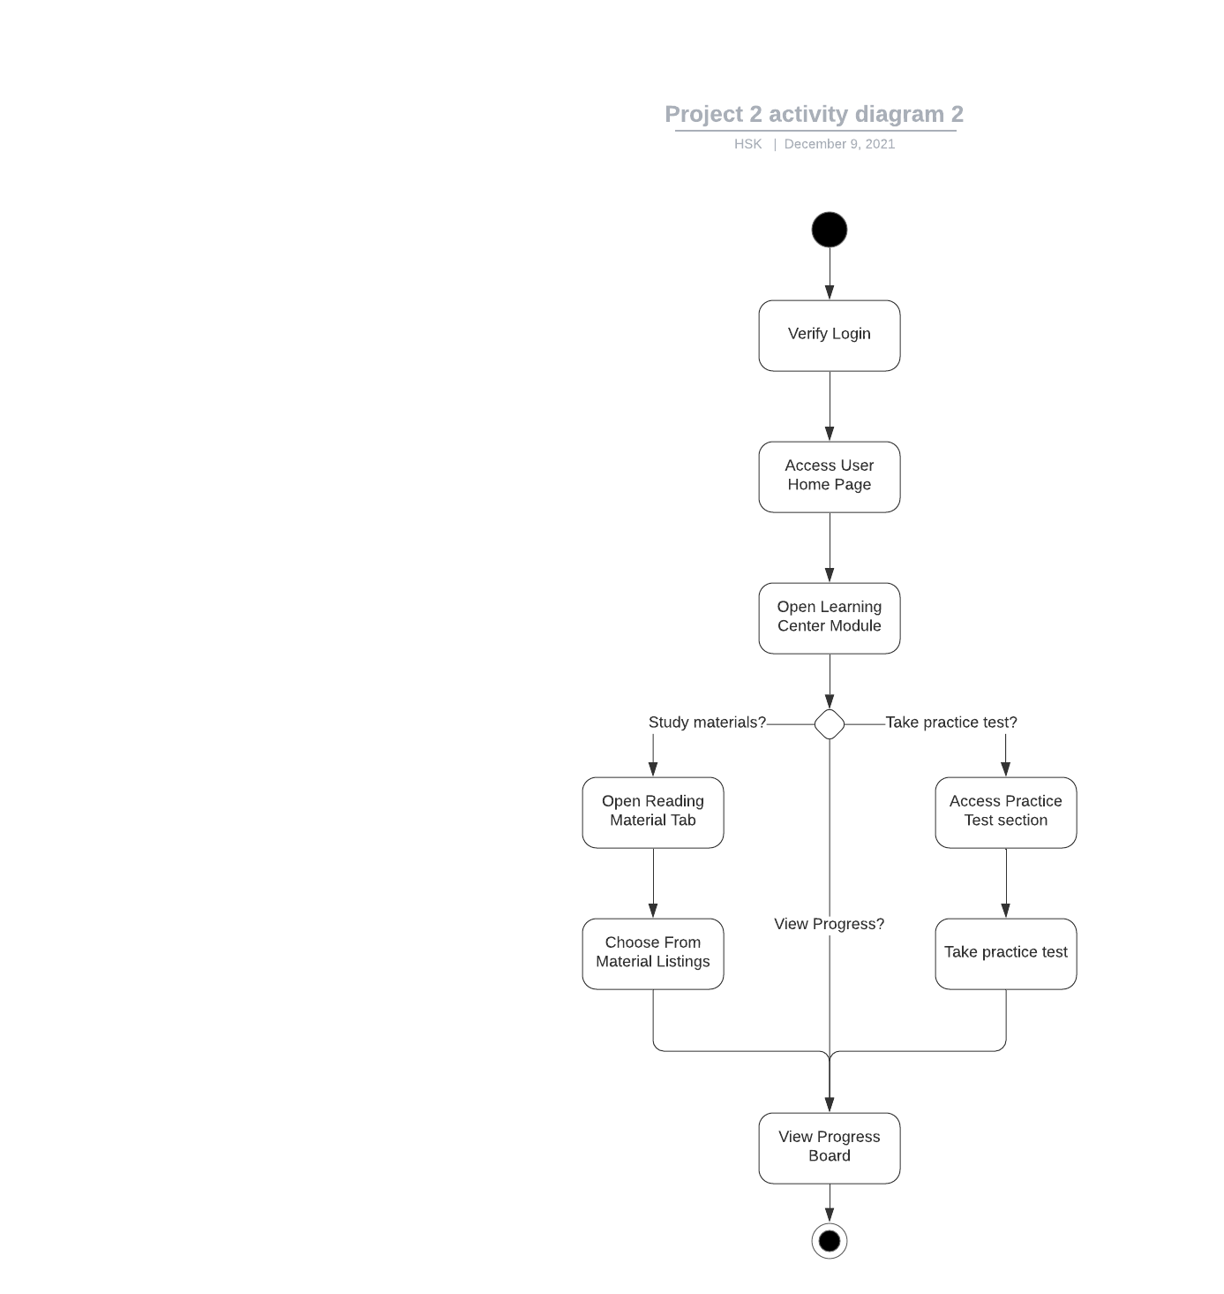

### UML Sequence Diagram

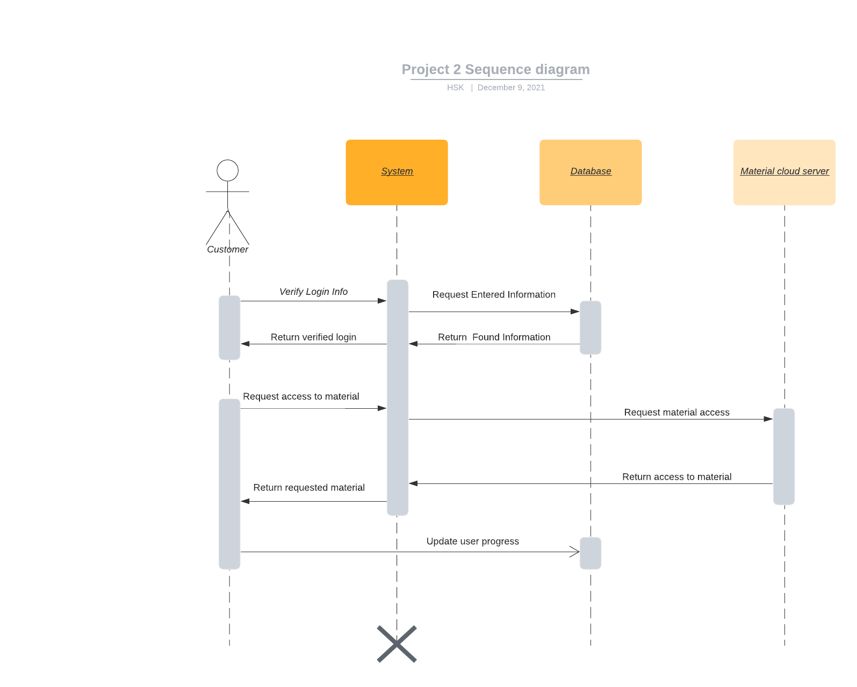

### UML Class Diagram

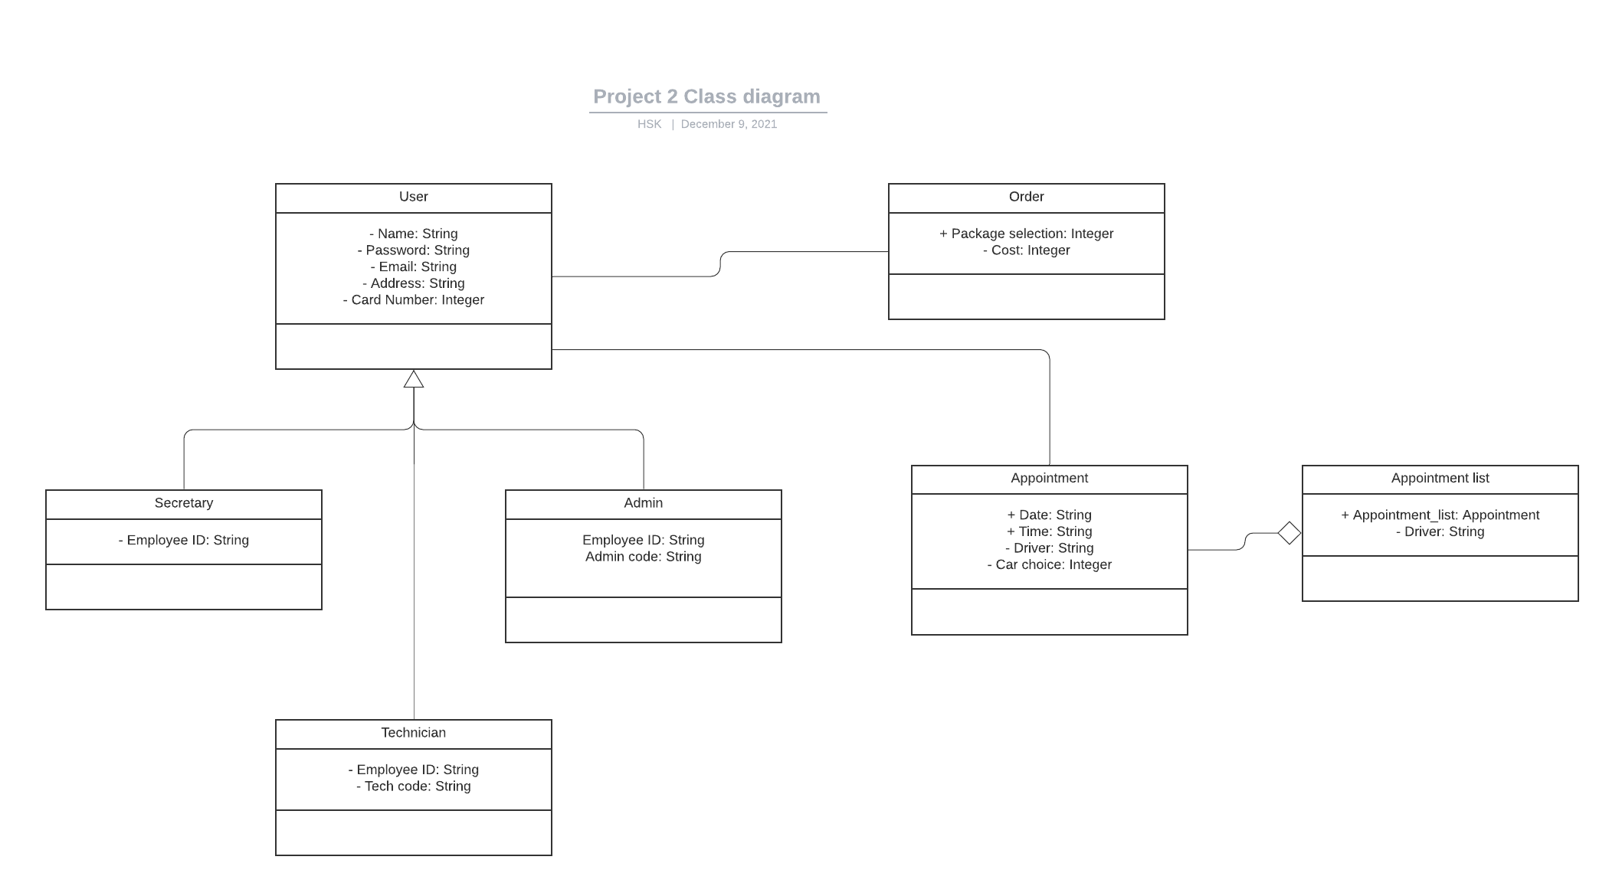

## Technical Requirements

*For the System the client is wanting to create we are going to need a cloud service of some kind. It may be cheaper to pay for a service rather than try and create one of our own. The system will need to have a couple of databases for learning material storage, along with one for account and appointment storage. Since most cloud services come with their own layers of security, it would still be necessary for the company to have their own security measures in place. Outside of security, the system will need to handle potentially large quantities of people that could all be trying to create an appointment. Finally, the system will need to create a list that will hold the potentially large number of appointments the company could get, and would allow them to structure the appointments to their liking.*